TASK 1

1. Write a program to show classes of umbrella and provide the polymorphism mechanism in umbrella open(), close(), waterproof().

CODE:

class Classic_Umberalla:

def __init__(self,material,style,prints,size,used_for):

self.material=material

self.style=style

self.prints=prints

self.size=size

self.used_for=used_for

def ForRain(self):

return("This is the most common type of modern foldable umbrellas. Commonly made with {} to keep the rain off, these umbrellas are your everyday portable shelters from storms.Its style is {} and its printing is{} Its size is {}.This Umbrella is used for Both {} \n".format(self.material,self.style,self.prints,self.size,self.used_for))

def WaterProof(self):

return("This classic umbrella comes with a black waterproof case. Put the umbrella in the case to stop water leaking in your car, bag floor etc.\n")

def Open_close(self):

return("In this umberalla their is button to open and close \n")

class Bubble_Umbrella:

def __init__(self,fmaterial,fstyle,fprints,fsize,fused_for):

self.fmaterial=fmaterial

self.fstyle=fstyle

self.fprints=fprints

self.fsize=fsize

self.fused_for=fused_for

def ForSunprotection(self,colors):

self.fcolors=colors

return("This is the most commmon type of foldable umbrella.commonly made up of {} to Sunprotection and rainfalls.These are great for {} who love to peer out at the rain while keeping their faces dry.Its style is {} and its printing is{} Its size is {}.Its has diffrents colos {} \n".format(self.fmaterial,self.fused_for,self.fstyle,self.fprints,self.fsize,self.fcolors))

def WaterProof(self):

return("This Bubb;le umbrella not come in water proof.Because it mostly use to protectsunshineand its is made form kids ")

def Open_close(self):

return(" It allows you to open the umbrella quickly using one hand. Push the button once to automatically extend the umbrella open, press again to instantly fold the Umbrella.\n")

CU=Classic_Umberalla("metal of polyesther shafts with microfiber fabric canopys","Classic","Screenprinting","20 to 40 inches","Adults and kids")

BU=Bubble_Umbrella("clear plastic","Kids","Bubble","Digital printing","20 to 40 inches")

print(CU.ForRain())

print(CU.WaterProof())

print(CU.Open_close())

print(BU.ForSunprotection("[red,green,blue]"))

print(CU.WaterProof())

print(CU.Open_close())

# Result

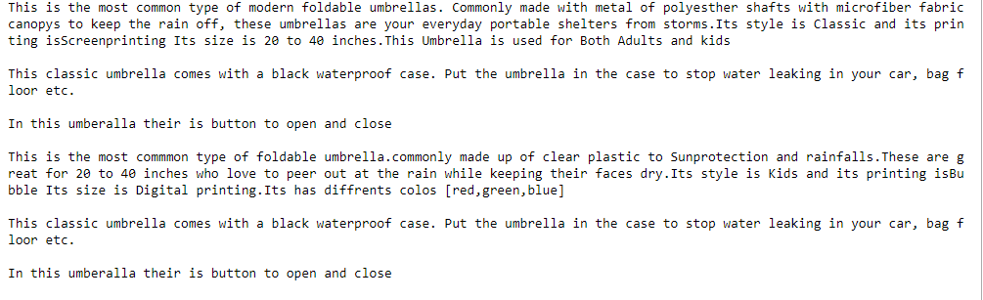

TASK 2

2. Design class for classical, and latest mobiles. Use polymorphism to show the functions of these mobiles such as button() or touch(), size(), split_screen(), operating_system(). Etc.

CODE:

class HUAWEI_Mobile:

def Screen_size(self):

return("The screen_size of HUWAEI_Y9 is 6.5inches")

def Microprocessor(self):

return("The processor used in HUWAEI_Y9 is 2.2GHz octa-core")

def size(self):

return("The size of Mobile is ")

def Display(self):

return("The display type of HUWAEI_Y9 is IPS LCD")

class samsung_Mobile:

def Screen_size(self):

return("The screen_size of Samsung Note 10 is 6.3 inches")

def Microprocessor(self):

return("The microprocessor used in Samsung Note 10 Snapdragon 855")

def size(self):

return("The size of samsung Note 10 is 151 x 71.8 x 7.9 mm")

def Display(self):

return("The display type of Samsung Note 10 is Dynamic AMOLED")

class Infinix_Mobile:

def Screen_size(self):

return("The screen size of Infinix_Hot 8 is 6.52 inches")

def Microprocessor(self):

return("The processor used in Infinix_Hot is Quad-core 2.0 GHz Cortex-A53")

def size(self):

return("The screen Size of Infinix_Hot 8 165 x 76.3 x 8.7 mm ")

def Display(self):

return("The display typeof infinix Hot 8 is IPS LCD capacitive touchscreen ")

HUA=HUAWEI_Mobile()

SAM=samsung_Mobile()

INF=Infinix_Mobile()

for Mobile in (HUA,SAM,INF):

print(Mobile.Screen_size())

print(Mobile.Microprocessor())

print(Mobile.size())

print(Mobile.Display()+"\n")

# Result

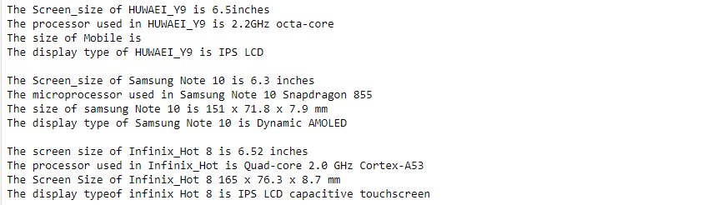

TASK 3

3 Design class for Butterfly. Such that butterfly has multiple colors, patters, nature of living, origin, living_in_pupa, living_as_caterpiller. Etc.

CODE:

class Butterfly:

pass

class BlueMorpho(Butterfly):

def Info(self):

print('They are the most rare butterflies. They are 1 out of thirty their time is mostly spent reproducing')

def color(self):

print('The color of this butterfly is dark blue')

def Pattern(self):

print('The butterfly wings are blue but they are black at the ends')

def origin(self):

print('They are basically found in Latin America Tropical forests in California')

def life_span(self):

print('The lifespan of blue morpho butterfly is 115 days')

class JanettaForester(Butterfly):

def Info(self):

print('They are the most colorful butterflies. They are they are listed to be 180 species')

def color(self):

print('The color of this butterfly are multi')

def Pattern(self):

print('The butterfly wings are blue,yellow and black in color')

def origin(self):

print('They are basically found in the African Continent')

def life_span(self):

print('The lifespan of Janetta Forester butterfly is unknown')

class Swallowtail(Butterfly):

def Info(self):

print('Swallowtail butterflies are large, colorful butterflies in the family Papilionidae, and include over 550 species')

def color(self):

print('Colour patterns may vary, although many species have yellow, orange, red, green, or blue markings on an iridescent black, blue, or green background.')

def Pattern(self):

print('The butterfly wings are blue,yellow and black in color with leaf pattern on them')

def origin(self):

print('The majority of swallowtail species and the greatest diversity are found in the tropics and subtropical regions')

def life_span(self):

print('The lifespan of swallowtail butterfly is about 10 to 12 days.')

sub1=BlueMorpho()

sub2=JanettaForester()

sub3=Swallowtail()

for butterfly in (sub1,sub2,sub3):

print( butterfly.Info())

print( butterfly.color())

print( butterfly.Pattern())

print( butterfly.origin())

print( butterfly.life_span())

# Result

